Automata Design
- Identifier
RE: [A-Z][a-z0-9]{0,30}
NFA:
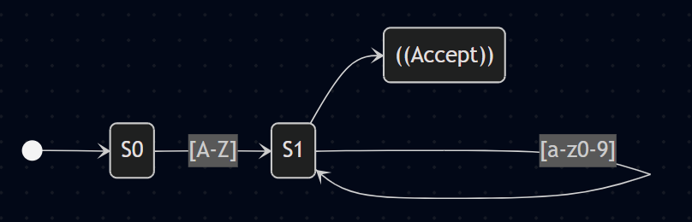
Minimized DFA:
Transition Table:
State | Input: [A-Z] | Input: [a-z0-9] | Other | Accepting?
S0 | S1 | Error | Error | No
S1 | Error | S1 | Accept | Yes

- Integer Literal
RE: [+-]?[0-9]+
NFA:
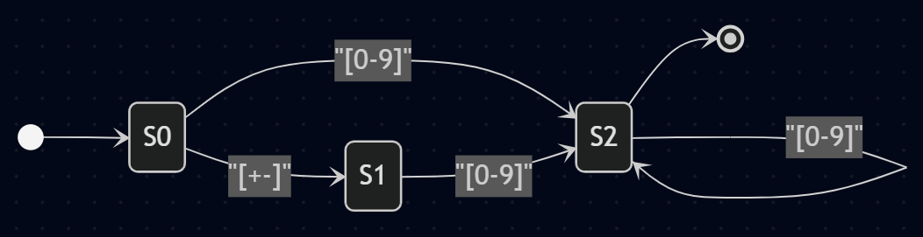
Minimized DFA:
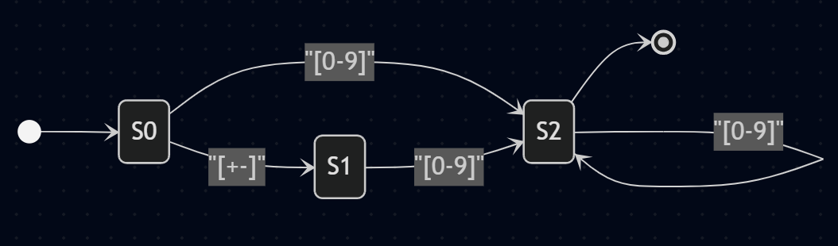
Transition Table:
State | Input: [+-] | Input: [0-9] | Other | Accepting?
S0 | S1 | S2 | Error | No
S1 | Error | S2 | Error | No
S2 | Error | S2 | Accept | Yes

- Floating Point Literal
RE: [+-]?[0-9]+\.[0-9]{1,6}([eE][+-]?[0-9]+)?
NFA:
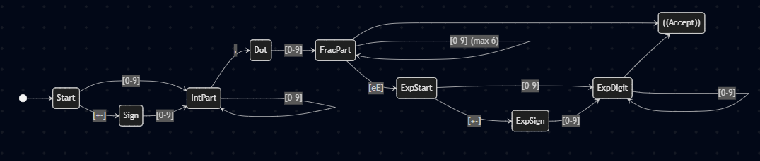
Minimized DFA:
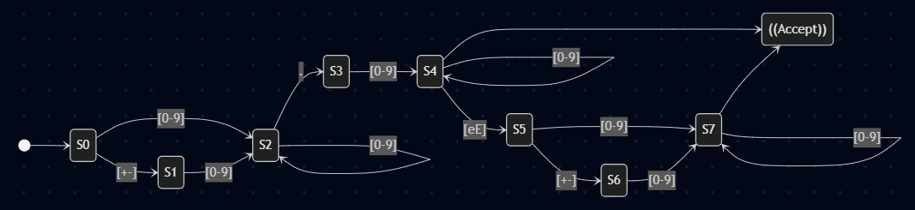
Transition Table:

State | [+-] | [0-9] | . | e or E | Other | Accept?
S0 | S1 | S2 | Err | Err | Err | No
S1 | Err | S2 | Err | Err | Err | No
S2 | Err | S2 | S3 | Err | Err | No
S3 | Err | S4 | Err | Err | Err | No
S4 | Err | S4 | Err | S5 | Accept | Yes
S5 | S6 | S7 | Err | Err | Err | No
S6 | Err | S7 | Err | Err | Err | No
S7 | Err | S7 | Err | Err | Accept | Yes

- Single Line Comment
RE: ##[^\n]*
NFA:
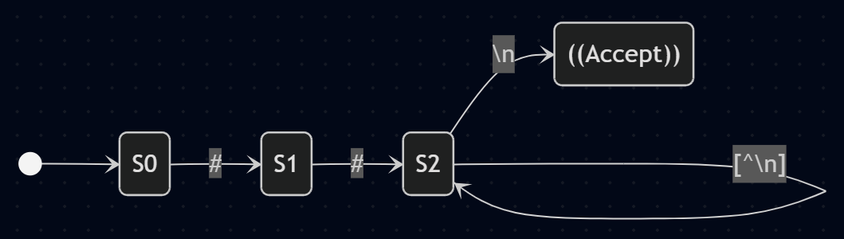
Minimized DFA:

Transition Table:
State | # | [^\n] | \n (Newline) | Other | Accept?
S0 | S1 | Err | Err | Err | No
S1 | S2 | Err | Err | Err | No
S2 | S2 | S2 | Accept | Err | Yes

- Boolean Literal
RE: (true|false)
NFA:
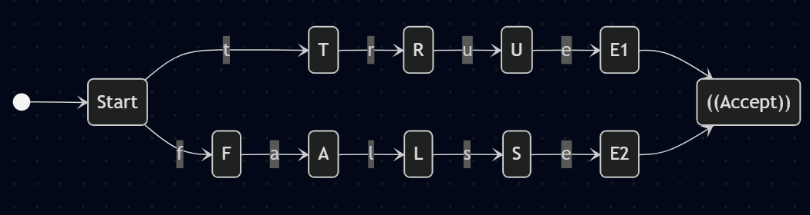
Minimized DFA:
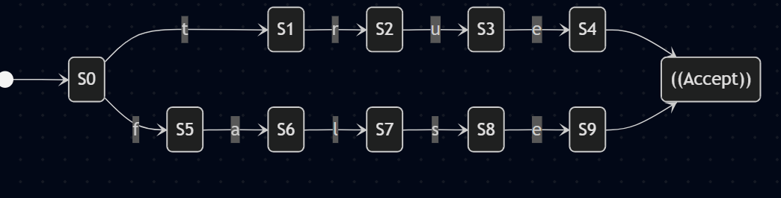
Transition Table:
State | t | r | u | e | f | a | l | s | Other | Accept?
S0 | S1 | Err | Err | Err | S5 | Err | Err | Err | Err | No
S1 | Err | S2 | Err | Err | Err | Err | Err | Err | Err | No
S2 | Err | Err | S3 | Err | Err | Err | Err | Err | Err | No
S3 | Err | Err | Err | S4 | Err | Err | Err | Err | Err | No
S4 | Err | Err | Err | Err | Err | Err | Err | Err | Accept | Yes
S5 | Err | Err | Err | Err | Err | S6 | Err | Err | Err | No
S6 | Err | Err | Err | Err | Err | Err | S7 | Err | Err | No
S7 | Err | Err | Err | Err | Err | Err | Err | S8 | Err | No
S8 | Err | Err | Err | S9 | Err | Err | Err | Err | Err | No
S9 | Err | Err | Err | Err | Err | Err | Err | Err | Accept | Yes

- Arithmetic Operator
RE: [+ - * / %]
NFA:
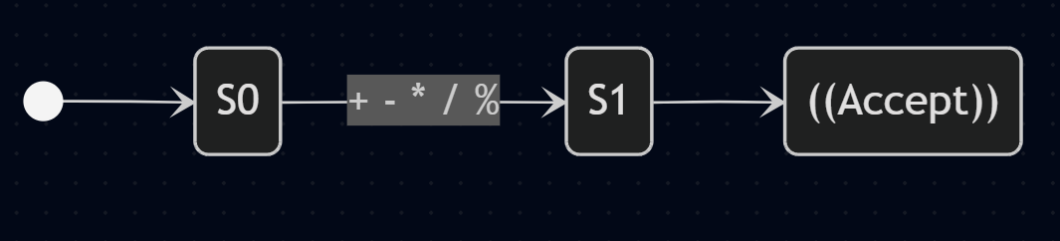
Minimized DFA:

Transition Table:
State | + - * / % | Other | Accepting?
S0 | S1 | Error | No
S1 | Accept | Accept | Yes

- Punctuator
RE: [(){}[\][,;:]]
NFA:

Minimized DFA:
State | ( ) { } [ ] , ; : | Other | Accepting?
S0 | S1 | Error | No
S1 | Accept | Accept | Yes
Transition Table:

